Drum Transcription with the expanded groove dataset

Thomas Holz, Deniz Özdemir

d.oezdemir@campus.tu-berlin.de

Abstract

1. Introduction

This paper was published during a student project from Thomas Holz and Deniz Özdemir at TU Berlin. This paper is related to a university module called Deep Learning in Audio Event Detection. The motivation behind this project was to develop an application for amateur musicians who are learning an instrument and need help in detecting notes from any drum recording. Furthermore, we think this application could help musicians in their studios, to play any drum pattern on different type of (drum) instruments. In this paper we will demonstrate how to get midi information out of raw audio files that contains drum recordings.

2. Related Work

This project is based on work of Lee Callender, Curtis Hawthorne and Jesse Engel[Quelle]. They introduced the Expanded Groove MIDI dataset (E-GMD), an automatic drum transcription dataset with 444 hours of audio content from 43 drum kits. They also documented time and velocity of human drum performances in midi notes. This dataset was fitted into a neuronal network model that was able to predict onset, drum hit, and velocity of drum recordings.

3. dataset

We used the Expanded Groove MIDI Dataset (E-GMD) (Quelle) for our train, test and validation datasets, which contain 444.5 hours of drum recordings and 45537 MIDI files. The dataset was recorded by 10 drummers, 5 professionals and 5 amateurs with 43 drumkits on a Roland TD-17. The sound varies between acoustic and electronic sounds. The drumkits were recorded at 44.1kHz and 24 bits. The drumkit contains 28 different instruments, which can be grouped into 7 hit and 3 hit classes to receive better results in the evaluation. Table 1 is showing the different type of instruemts.
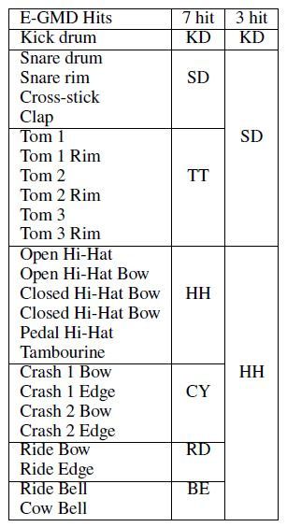

The dataset folder was divided into session folders and different drummer folders. So, it was necessary to split the wave and midi files into train, test and evaluation folders. A useful split was given by the authors of (Quelle) in a csv file. Because a manual split was no solution due to the huge amounts of files, we developed a python script that can assign the files automatically into train, test and validation folders. The script is available on our GitHub page (Quelle). In the following table you can see the distribution of the audio files.
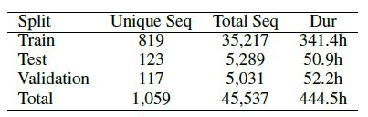

4. Preprocessing

Different from the paper of Lee Callender et al. (Quelle) we focused only on the onset prediction. Due to different lengths of wave files first we splitted each wave file into 1s slices. So we could guarantee that we have same input data for the model that we will use in the later process. After that we calculated the STFT spectrograms, which we filtered afterwards with a Mel-filter.

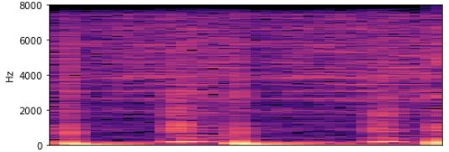

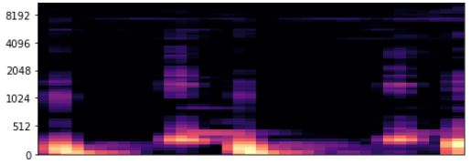

For the spectrogram calculations we choose a sample rate of 16kHz, the number of bins 64, and a hop length of 441. The window length and the number of frames for the STFT were 2048. We convolved the audio slices with Hann window function. Before we could fit our model with data we need to calculate the ground truth for each wave file.

5. ground truth

To get the ground truth for each wave slice we modified the GitHub code from Rainer Kelz (Quelle), who uploaded a code for midi detection of 88 different piano keys. Because in our case we only had 28 instruments, we modified the code for our purpose. We stored the midi information in a 2D Array with number of frames in the first dimension and the type of instrument in the second dimension. In our case it looked like this: [37,28]. The number of frames depended from the configuration of the sample rate, the audio length and the hop length with this realationship:

Number of frames = (sample rate * audio length / hop length)+1

The second dimension represented the type of the instrument that is playing at specific frame. Figure 4 is showing for example the instrument 6 playing at second frame. Because each instrument was assigned to random values between 22 and 75 we mapped the number of instruments to the bins 0 – 28 of the second ground truth dimension. We used the MATLAB framework “Miningsuite” to plot some parts of a random midi notes. So we were able to analyze how mid notes are constructed. In figure 3 the first 2s of a random midi note is visualized. The x-dimension is representing the timeline and the y-dimension is representing the type of instrument that is playing. For example, at second 0 the instrument 22 is playing for 0.08 seconds. The duration of the played instrument is visualized with a line. The onset of each played instrument is represented with a dot.
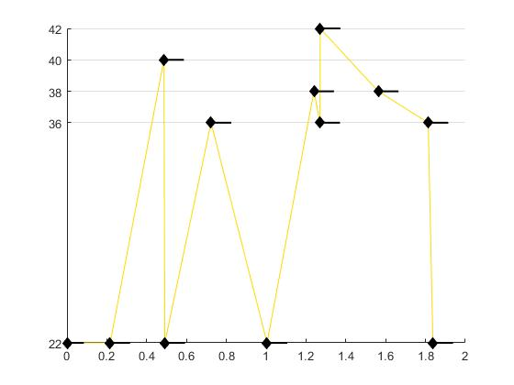

6. model

We used two different models for the onset prediction. The first model is illustrated in figure 4. The input of this model is (37, 64, 1). After the input a batch normalization layer followed.

8. performance measurements

9. discussion

11. outlook

12. References

